Part 1

Design Criteria
Your Mascot must:
- Appeal to the new school’s 5-7 year olds.
- Cover at least 60% of the My Q display area.

1. Your Design Criteria

Imagine a particular pupil.
What would make a mascot look appealing to that pupil?
List 3 criteria.

Criterion 1 _________________________________________________________

Criterion 2 _________________________________________________________

Criterion 3 _________________________________________________________

2. Rapid Sketching
a. Make 2 different sketches of your Mascot. Make them different. Be creative, but keep the design criteria in mind. | b. Estimate how much of the display area each Mascot occupies. Justify your answer.

Sketch A

Sketch A
Estimate of area used ____%

Justify your estimate:

Justify your design:

Sketch B

Sketch B
Estimate of area used _____%

Justify your estimate:

Justify your design:

3. Finalize Your Design

a. Use the DigiTool to make a pixel-by-pixel final design.

b. Explain how your final design meets all of the design criteria, including your own.

4. Print or take a screenshot of your Mascot design.

Part 2

1. New Handhelds, Different Size Displays

There will soon be 3 new My Q handhelds with different size displays. The requirements are in the table below. You can choose the widths and heights, but you must use the specified width to height ratio and meet the pixel requirement shown.

Handheld | width  (in pixels) | height  (in pixels) | ratio of width to height | pixels  greater than 3000
My Q (original) | 50 | 30 | 5:3 | exactly 1500
Super My Q |  |  | 5:3
Square My Q |  |  | 1:1 | about 1500
Portrait My Q |  |  | 3:5 | exactly 1500

2. Resizing Your Character

Choose a geometric shape to represent your Mascot, and use the DigiTool to draw the shape (or draw a shape that roughly matches the outline of your Mascot). Make sure that the shape covers about the same portion of the display as your Mascot did. For each of the new handheld display designs, use DigiTool to resize the shape to fit the new display. For each display, use
- The stretch tool; and
- The numbers tool.

3. Looking for Relationships

State as many relationships as you can among the numbers in the table.

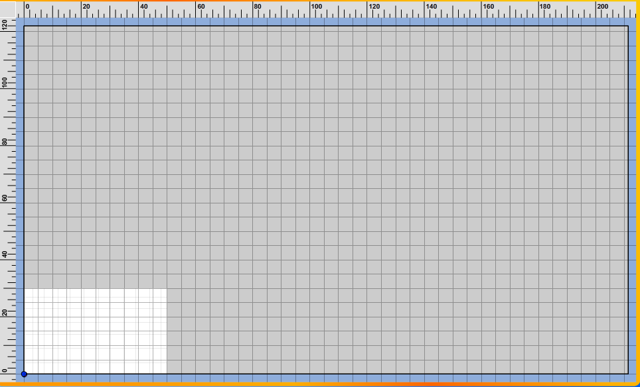
(workspace—you can try out your ideas here)
Original
My Q Display
Part 3

Design Criteria
Your Mascot must:
- Cover at least 60% of the My Q display area.
- Appeal to the new school’s 5-7 year olds.

1. Circles

a. What is the approximate area, in pixels, of the largest circle that can fit the original My Q screen (50 x 30)?

b. How do you know?

c. If your Mascot were shaped as a circle, would it meet the design criteria of covering at least 60% of the display area?
Explain why or why not.

d. Write an explanation so that the client can explain it to others.

2. Triangles

a. What is the approximate area, in pixels, of the largest triangle that can fit the original My Q screen (50 x 30)?

b. How do you know?

c. If your Mascot were shaped as a triangle, would it meet the design criteria of covering at least 60% of the display area?
Explain why or why not.

d. Write an explanation so that the client can explain it to others.

Part 4

Design Criteria

Your Mascot must:
- Cover at least 60% of the object’s display area.
- Appeal to the new school’s 5-7 year olds.

Object | width  (in pixels or cm) | height  (in pixels or cm) | ratio of width to height | pixels or cm²
My Q (original) | 50 | 30 | 5:3 | exactly 1500
T-Shirt
Coffee Mug

1. The Q School Mascot T-Shirt
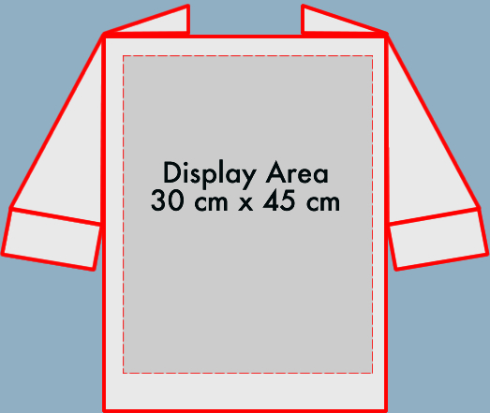
a. The t-shirt’s available display space is 30 cm by 45 cm. What is the area? (show your work)

b. Use the DigiTool to draw a shape that roughly matches the outline of your original Mascot. Make sure that the shape covers about the same portion of the display as your Mascot. Use DigiTool to resize the shape to fit the t-shirt display area. Use:
- The stretch tool; and
- The numbers tool.
For this activity the units on the scale on the axes of the DigiTool will be centimeters.

c. Explain how your Mascot design and dimensions would need to change to meet the design criteria for display on a t-shirt.

2. The Q School Mascot Coffee Mug
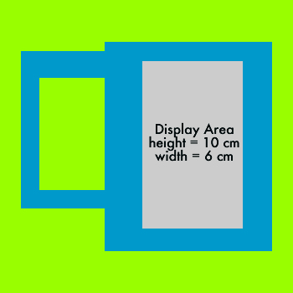
a. The coffee mug’s available display space is 6 cm wide and 10 cm tall. What is the area?

b. Use the DigiTool to resize your shape to fit the coffee mug display area. Use:
- The stretch tool; and
- The numbers tool.
For this activity the units on the scale on the axes of the DigiTool will be centimeters.

c. Explain how your Mascot design and dimensions would need to change to meet the design criteria for display on a coffee mug.

